db.createCollection('books') # Creates new collection called books

db.books.insert( # Inserts each book

{

isbn: "999-888",

book: "The secret river",

author: "Kate Grenville",

reviews:

[

{reviewer: "Hua Tang", score: 7},

{reviewer: "Jim Wong", score: 8},

{reviewer: "Andrea Bauer", score: 6}

]

}

)

db.books.insert(

{

isbn: "777-222",

book: "Fooled by randomness",

author: "Nassim Taleb",

reviews:

[

{reviewer: "Simon Jones", score: 5},

{reviewer: "John Messum", score: 10}

]

}

)

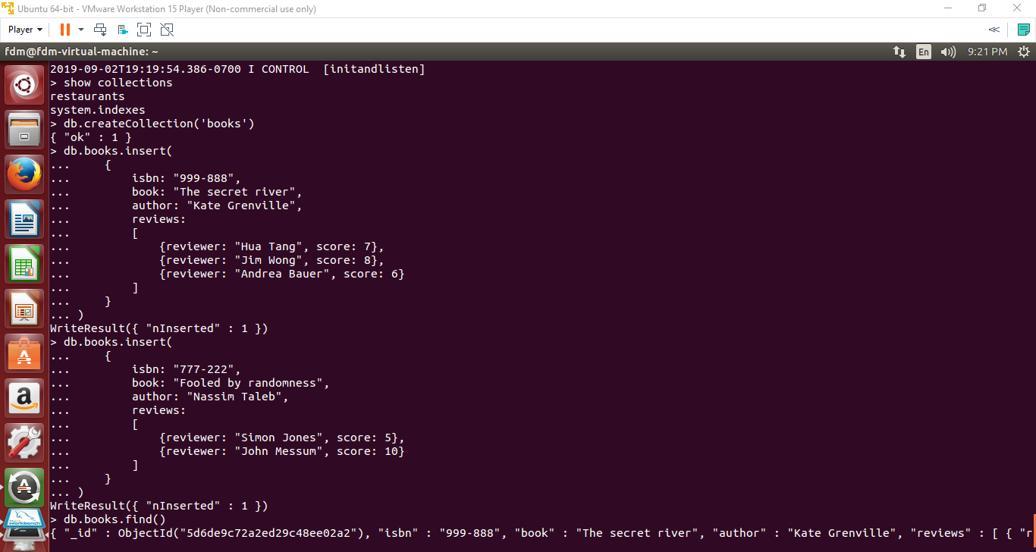

After inserting each book, the terminal returns WriteResult({ “nInserted”: 1 }) to confirm that the book has been added to the collection successfully.